DRAFT December 17th 2019

***Novel approach to Diamond upgrade through studies of an Accelerator-Beamline integrated system***

M. Apollonioa, F. Bakkali-Taheria, R. Bartolinia,b, J. Lib

*a Diamond Light Source, Oxfordshire, U.K.*

*bJohn Adams Institute, University of Oxford, U.K.*

Abstract

At Diamond Light Source we are considering an upgrade of the machine aimed at a significantly reduced emittance (a factor 20), that follows a world-wide trend in similar synchrotron radiation sources. An important aspect in the design of the upgrade is the optimization of the photon beam properties, such as flux, brightness, spot size, divergence or coherence of the new sources and how these are translated into requirements on the electron beam and on the machine design. We have developed a strategy to bridge the gap between machine lattice design and beamline needs, that is substantially based on an integrated use of accelerator physics tracking codes (elegant[1]) and of radiation codes (SRW[2], SHADOW[3]). The paper is structured as follows: in section 1 we give an introduction to Diamond with a comparison to the new low emittance machine we are considering for its upgrade (Diamond-II). In section 2 we present the Python code used to run the electron beam tracking section, based on elegant, followed by the wavefront propagation through the beamline with SRW. The code allows to easily study the response of the system to external variations, either orbit changes in position and angle at the source point, or to the linear optics of the system (local variation of Twiss parameters). Section 3 describes the optimisation of the system based on a multi-objective genetic algorithm, applied to the beamline, the Twiss parameters defining the linear optics at a source point and a combination of the two. Section 4 completes the paper with few considerations on the use of SRW and some indications for future work.

*Keywords: Diamond, Diamond-II, low emittance lattices, electron beam, photon beam,electron beam tracking, wave-front propagation, multi-objective optimisation, genetic algorithms.*

# Introduction

Diamond Light Source [1] is a third generation synchrotron machine, with a circumference of 561.571 m, working in top-up mode at an average current of 300 mA, a beam energy of 3 GeV with a typical equilibrium emittance of 2.7 nm rad. Dedicated feedback systems are in place to ensure a very good control of the main parameters, such as the orbit, the tune working point and the vertical emittance, typically kept at 8 pm rad. The present machine parameters are reported in Table 1 together with a possible future realization of a low emittance machine [2].

Table 1 main parameters of Diamond and Diamond-II lattices

|  |  |  |  |  |
| --- | --- | --- | --- | --- |
| Lattice | Ebeam (GeV) | Ibeam (mA) |  (pm) |  (%) |
| Diamond (DBA) | 3.0 | 300 | 2700 | 0.3 (8pm) |
| Diamond-II (M-H6BA) | 3.5 | 157 | 5.0 (8pm) |

Diamond has been in operation for over eleven years, during which a total of 32 beamlines have been integrated into the machine in three main phases. Insertion devices (ID), such as undulators and wigglers, and bending magnets (BM), are used as synchrotron radiation sources. Initially built as a 6-fold super-period lattice based on 24 Double Bend Achromat (DBA) cells, Diamond underwent two important changes. In 2009 and 2011 two vertical mini-beta sections with horizontal virtual focusing (HVF) were introduced in straight 9 and 13. In 2016 a Hybrid Multi-Bend Achromat with 4 dipoles (4-HMBA) cell, also known as Double Double Bend Achromat (DDBA), was inserted in lieu of cell 2, creating an extra mid-straight to host a new undulator [3]. The DDBA concept, when replicated 24 times with a super-period 6, was the original baseline case for Diamond-II, giving a natural emittance of about 270 pm. A further development is the 6-HMBA cell, promising a natural emittance of about 157 pm [2]. Other low emittance lattices have been developed and are under study at Diamond. The optimisation of electron and photon beams in a new machine requires a careful process of investigation of the needs of each single line (or at least the main classes into which beamlines can be grouped), entailing the use of accelerator physics codes for the definition of the electron beam parameters, and radiation codes to establish the properties of the photons emitted at the source points inside the ID's and BM's. Radiation can then be propagated towards the beamlines at different depths, from the front-ends (FE), to the sample or detector planes. These latter cases require a complete model of the beamline optics (mirrors, crystals, slits, lenses and so forth). In order to tackle all these issues we felt that the standard working model where the electron storage ring (SR) and the beamlines (BL) are seen as separated entities, should be changed into an integrated vision of the problem improving the scope of both and leading to a better comprehension of the system as a whole.

One of our main goals is the identification of parameters aimed at quantifying the performance of a beamline. These Key Performance Parameters (KPP) help to guide the lattice design group, by defining a set of quantitative objectives to be targeted. We illustrate this by considering two beamline case-studies. KPPs are defined with a careful work of consultation with the beamlines, expressing their requests and concerns related to the new machine. These parameters can substantially differ from one beamline to another.

# The Electron to Sample code

As described in the previous sections, our aim is to identify the KPPs for all the beamlines, in order to facilitate the transition towards a new machine. Past experience shows that an integrated approach with a complete simulation from the electrons generating the synchrotron radiation, to the final sample plane could be a valuable tool for a general optimisation of the system. To this goal we developed a code, wrapping up the main packages commonly used in the Accelerator Physics and in the Synchrotron Radiation and Optics communities. This program, named electron to sample (e2s) is written in Python, and at present is making use of the codes elegant [4], for the accelerator part, and SRW [6] or SHADOW [5] for the propagation of the photons. An input file defines the run to be implemented, specifying the lattice to be used, the source position in the storage ring and the parameters defining the ID. The program starts by launching an elegant session and

by calculating the Twiss parameters at the chosen source point. These parameters are then translated into beam sizes and passed to the photon code performing a wave-front propagation in the case of SRW. Ray-tracing calculations can also be performed by means of other available external codes, like SHADOW, as explored in [7]. Likewise the AP tracking code could be substituted by other packages, like AT []. However, for this work, we focused our efforts on the interplay between elegant and SRW, reserving the use of different codes to a future work.

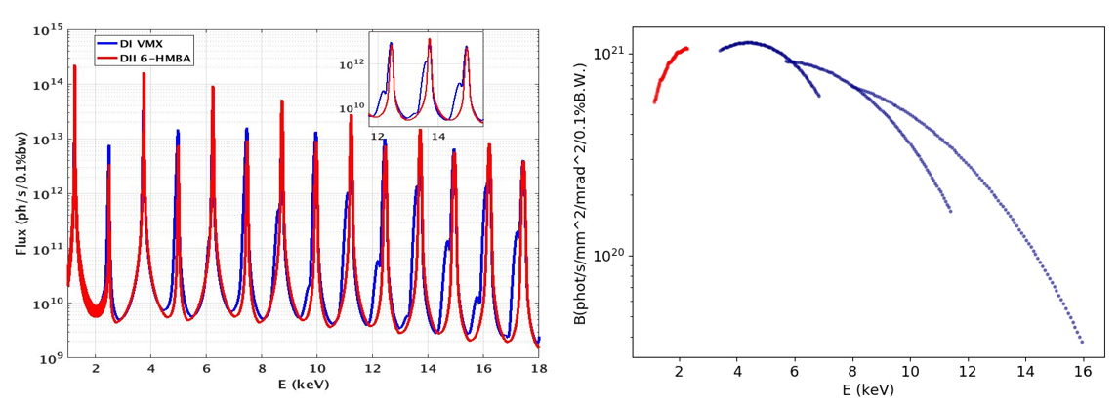

Figure 1 (Left) partial flux at I13-coherence beamline front-end (slit of [300,120] m), showing the increase due to the reduced emittance, (right) tuning curves for the same device.

The code allows the calculation of basic quantities (fluxes, brilliance, power densities) as shown for example in Fig. 1 where the left picture illustrates the comparison of the total fluxes through a slit between the present machine and Diamond-II for beamline I13-coherence branch. In the same figure, on the right, a tuning curve graph is shown for the same beamline.

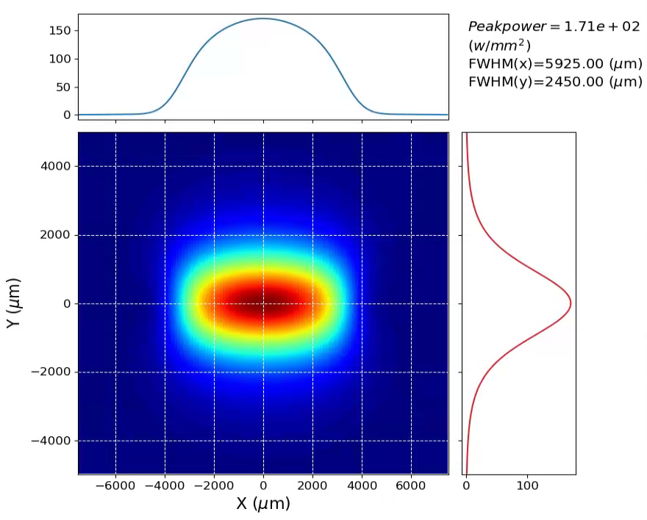

Figure 2 power density computed at the front-end of I13-coherence branch.

An example of power density calculation is displayed in Fig. 2.

In the remaining part of the paper we will focus on the use of e2s for the propagation of SR through whole beamlines, and will present some optimisations based on the intensity pattern collected at the sample plane.

## Effect of Orbit Corrections

One important aspect when operating a beamline, is understanding the effects of variations in the electron beam orbit in the region where the insertion device is located. Changes in the transverse position and angles can propagate through the beamline up to the sample plane where the final image is collected. While pairs of primary BPMs are typically used to keep control of the orbit locally, it is quite common to witness cases of mis-alignments of the beam with respect to the ID, or corrector drifts. Sometimes offsets at these BPMs are deliberately applied in order to align the beam with respect to the ID, albeit some residual relative shift or angle may be present. All these effects can eventually degrade the properties of the transmitted radiation, either moving the position of the beam-spot at the sample plane or reducing its intensity or both. The code we have developed is suited to reproduce these effects of orbit change in the machine. As an example we take the case for Diamond beamline I13, coherence branch [].For the studies we considered a photon energy tuned to the 7th harmonic (11.209 keV). Before delving into the study of the beamline, we took some steps to characterize few key elements of the system. As a first check we verified the effect of the Si111 crystal quad-monochromator (QCM) in I13-coherence, as a function of energy changes: if the monochromator is tuned to transport a given energy, then the beam is fully transmitted only within a narrow band. The reflectivity curve for a single Si111 crystal is calculated for an energy scan, and is compared to an angular scan to illustrate the equivalence of the selecting power given by such system. The tilt is generated by means of the CRL, by shifting the beam sideway as described in detail in par. 2.1.2.

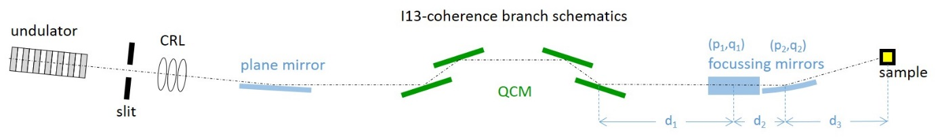

Figure 3 A schematic top view of DLS beamline I13 coherence branch model used in this study.

The photons after the lens will therefore be tilted and collimated, approaching an ideal pencil beam case and minimizing the effects of resolution. Fig.4 summarizes the calculation and shows the comparison with a typical rocking curve as found in [Xoh].

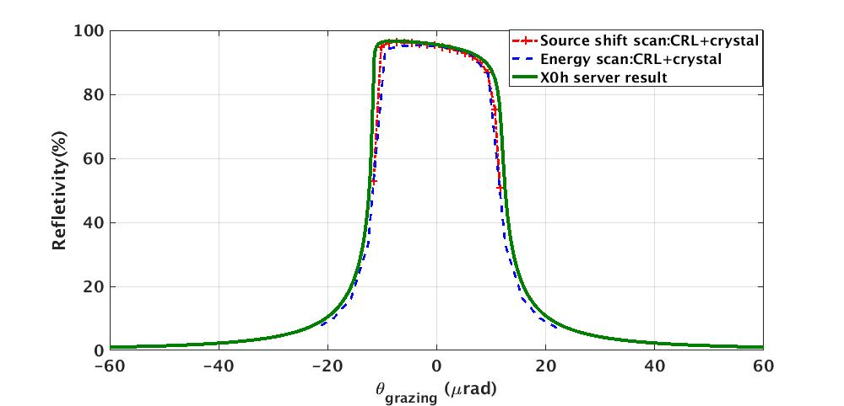

Figure 4 reflectivity curve obtained by scanning the energy of a beam through a single Si111 crystal (blue dashed curve), and by tilting and collimating the incoming beam by means of a CRL lens (red dashed curve). This is consistent with the theoretical result as found in [] (green curve).

### Orbit tilts

As discussed in the previous paragraph, one key optical element of this beamline is given by the CRL lens, which is used to collimate the beam. Assuming a horizontal tilt for the source equal to $δx^{'}$ and a CRL focal length f, the effect of an initial drift D1 to the lens followed by the focussing of the CRL can be parametrized by:

$$\left(\begin{matrix}1 & 0 \\ -\frac{1}{f} & 1\end{matrix}\right)\left(\begin{matrix}1 & D_{1} \\ 0 & 1\end{matrix}\right)\left(\begin{matrix}0 \\ δx^{'}\end{matrix}\right)=\left(\begin{matrix}δx^{'}D_{1} \\ \left(1-\frac{D_{1}}{f}\right)δx^{'}\end{matrix}\right) (1)$$

In our case, *D1* is equal to 21.549m, and *f* is equal to 21.573m. The ratio of these quantities is very close to 1, making the system *de facto* insensitive to initial tilts by design (collimation). For this reason the grazing angle at the monochromator is basically unchanged, while the beam spot after the lens appears to be shifted by a quantity equal to $δx^{'}D_{1}$. The overall effect at the sample plane is illustrated in Fig. 5,

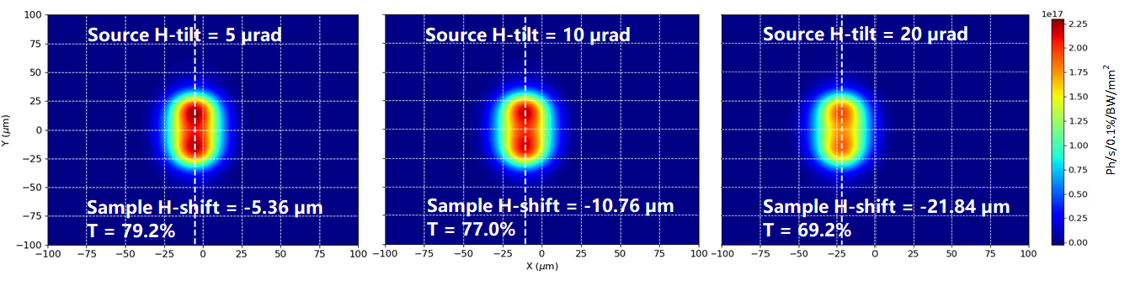

Figure 5 Effect of orbit angular tilts in the horizontal plane at the centre of the ID，for three different tilts at the source: (left) 5 µrad, (centre) 10 µrad and (right) 20µrad.

Where a fairly linear response is observed. A reduction in transmission is also observed which is mainly due to the amount of Berillium crossed at the CRL, as graphically summarized by Fig. 6.

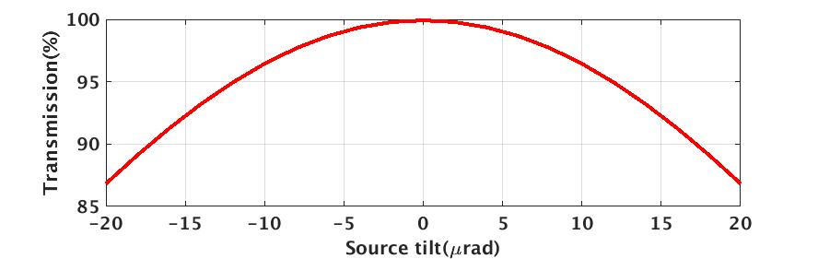

Figure 6 *Transmission curve of CRL corresponding to angular tilts of the source from -20 to +20 µrad.*

### Orbit shifts

When the beam is shifted horizontally, the CRL will introduce an angular change of $-\frac{δx}{f}$, as can be inferred from equation (2):

$$\left(\begin{matrix}1 & 0 \\ -\frac{1}{f} & 1\end{matrix}\right)\left(\begin{matrix}1 & D_{1} \\ 0 & 1\end{matrix}\right)\left(\begin{matrix}δx^{ } \\ 0\end{matrix}\right)=\left(\begin{matrix}δx \\ -\frac{δx}{f}\end{matrix}\right) (2)$$

Since the monochromator is set to transmit a well defined energy corresponding to the Bragg condition, any angular tilt will result in a reduction in transmission, which is clearly capture in Fig. 7 (right).

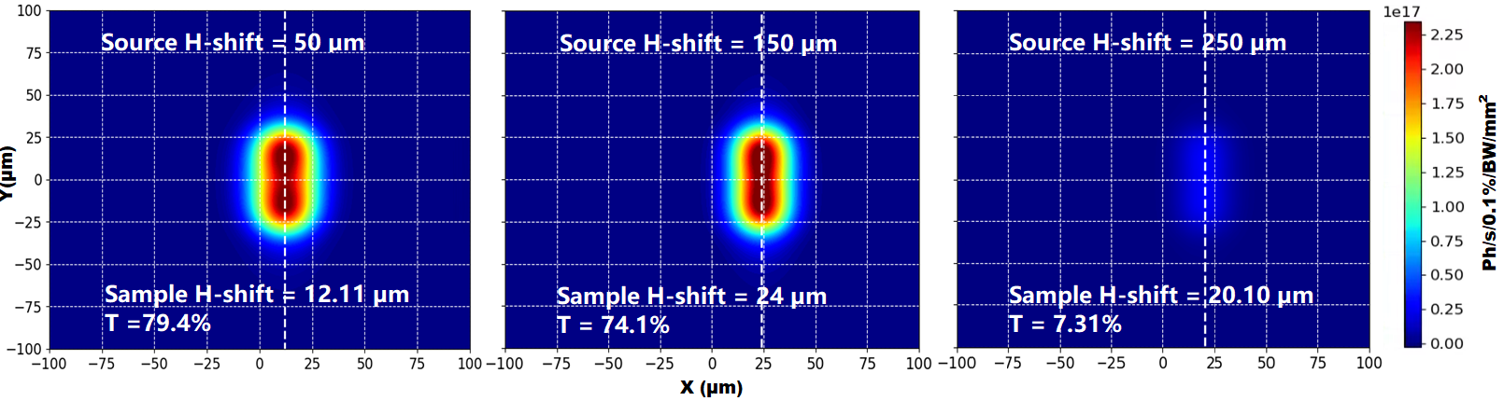

Figure 7 *Orbit side shift in the horizontal plane at the centre of the ID, for three different displacements at the source: (left) 50* µm*, (centre) 150* µm *and (right) 250* µm*.The sharp decrease in intensity (leftmost picture) corresponds to an impingning angle of about mrad, falling out of the energy bandwith for our monochromator.*

### Transmission through the beamline

The overall transmission budget, shown on Fig. 10 for different shifts and tilts of the source, summarizes our understanding of the main processes happening during the propagation of the wave-front through I13-coherence. CRL and monochromator are both equally important when tilting the beam, while the monochromator becomes the dominating element for large shifts due to the bandwidth considerations given in section 2.1.2.

In Fig. 11 we show the transmission curve of the four bounce monochromator as a function of the grazing angle –dx/f due to a shift scan, compared to an energy scan curve. The typical asymmetry shown in Fig. 4 is still present for the energy scan, while is completely lost in the shift scan, the blue curve being completely symmetric. The main reason for this behaviour is due to the (p/2, 3/2pi, 3/2pi, pi/2) orientation of the crystals, as can be seen in Fig. 12.

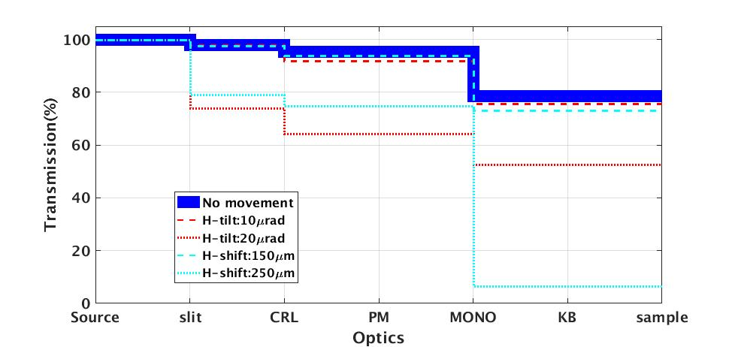

Figure 8 *Transmission change along the whole beamline corresponding to source movements. In this case we adopted a slit of 600x200 m2 whose effect is clearly visible at large shifts and tilts. The effect due to the finite sizes of the optical elements is minimal.*

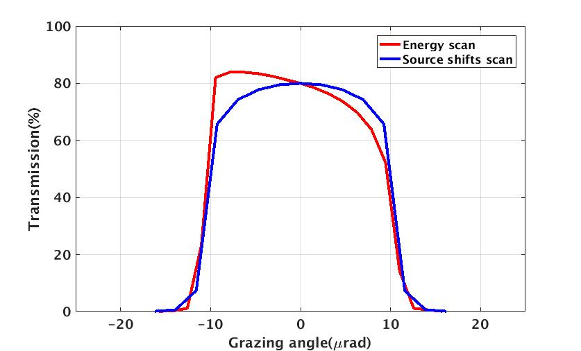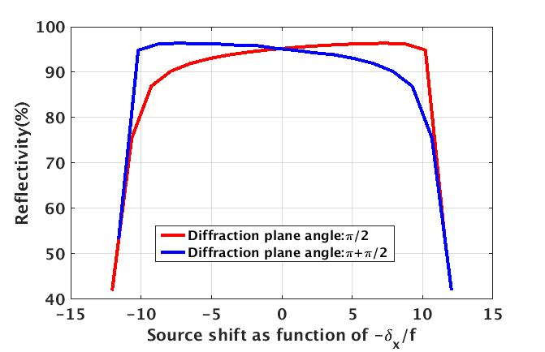

Figure 9 (left) *transmission curve for the Si111 crystal monochromator from energy (red) and source shifts (blue) scan as computed by SRW in e2S. The energy dependence is translated into its Bragg angle equivalent, shifts scan curve is plotted agains an angle defined by the CRL focussing formula $-\frac{δx^{ }}{f}$. We symmetric behaviour of the transmission due to different impinging angles is essentially due to the crystal arrangement used in the four bounce monochromator, as explained in the text.*

A summary of the effect of beam orbit variations at the source point is presented in Table 2.

Table 2 summary of the effects of shift and tilt of the orbit at the source position

|  |  |  |  |  |
| --- | --- | --- | --- | --- |
| Shift / Tilt | Total photons | x (m) | y (m) | x-centre (m) |
| 0 | 3.99x1014 [79.8%] | 10.35 | 20.88 | -0.06 |
| 50 (m) | 3.97x1014 [79.4%] | 10.79 | 20.90 | 12.11 |
| 150 (m) | 3.70x1014[74.1%] | 9.76 | 20.97 | 24.00 |
| 250 (m) | 3.65x1013[7.31%] | 10.70 | 21.69 | 20.10 |
| 5 (rad) | 3.96x1014 [79.2%] | 11.05 | 20.89 | -5.35 |
| 10 (rad) | 3.85x1014 [77.0%] | 11.16 | 20.90 | -10.76 |
| 20 (rad) | 3.46x1014 [69.2%] | 11.86 | 21.10 | -21.84 |

## Effect of Lattice parameters changes

Modifications of the local lattice optics, either deliberate or simply due to residual beating caused by non-perfect linear optics definition, may have an impact on the final image formed at the sample position. The code we developed allows to explore these effects in a systematic away, and to devise a correction strategy. Considering the case of I13-coherence we explored the formation of the image at sample (see Fig. 5) as a function of perturbed Twiss parameter at the source, which is a straightforward implementation in the e2s code. Fig. 6 shows the variation of the image size at sample, obtained when the Twiss parameters at the source are scanned individually.

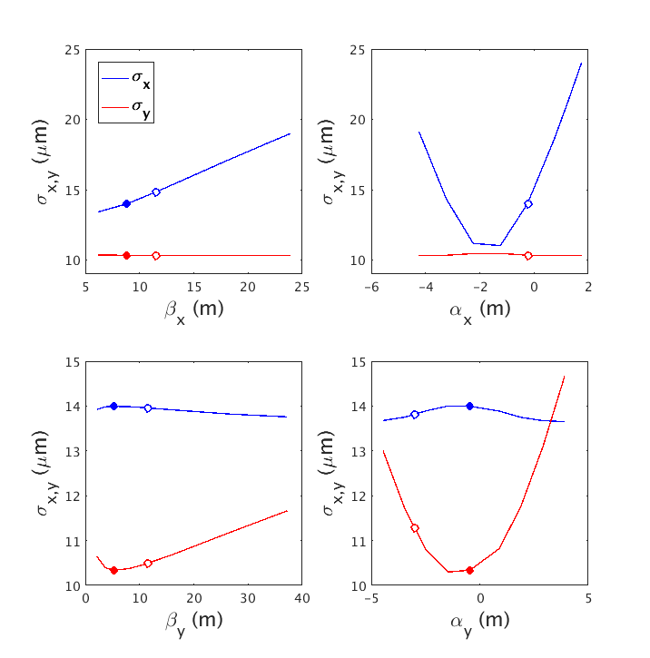

Figure 10 image size variation at the sample plane in beamline I13-coherence for individual scans of the Twiss parameters. Full dots, original MH6BA lattice for Diamond-II. White dots: Twiss parameters altered to illustrate the response matrix method in a linearity region.

We observe that, for the lattice considered here, the formation of the image exhibits a clearly non-linear behaviour, especially in the y-component. For example, a variation around the present working point of y, can be barely appreciated in terms of image size (bottom left quadrant in Fig. 10). A similar consideration applies to the scan in y (bottom right quadrant in the same figure).

Following a standard technique used in the Accelerator Physics community, a Twiss Response Matrix (TRM) of the beamline can be built which describes the beamspot variations for given modifications of the optics parameters at the source. This assumes a linear response of the system to the aforementioned changes, while the case under study can be highly non-linear especially when we try to focus a beam spot. Therefore, in order to illustrate the method we re-define the original working point (full coloured circles in Fig. 10) and build the TRM around a new set of working points (white hollow circles).

Table 3 illustrates the parameter modifications and the consequent variations seen in the beamline that are utilized to build the TRM of I13-coherence.

Table 3 effect of Twiss parameter modifications at source location on the beamspot size and photon intensity at sample position for beamline I13-coherence branch.This table has been use to compile a TRM for I13-coherence beamline.

|  |  |  |  |  |  |  |  |  |
| --- | --- | --- | --- | --- | --- | --- | --- | --- |
|  | |  | (m) | | | | (ph/s/0.1%BW/mm2) | |
| initial Twiss parameter | |  | x- | x+ | y- | y+ | I- | I+ |
| x (m) | 11.5 | ±0.5 | 14.69 | 15.03 | 10.17 | 10.17 | 3.62 | 3.54 |
| x | -0.24 | ±0.25 | 13.07 | 15.08 | 10.20 | 10.17 | 4.07 | 3.53 |
| y (m) | 11.5 | ±0.5 | 14.02 | 14.03 | 10.21 | 10.15 | 3.81 | 3.79 |
| y | -3.0 | ±0.25 | 13.78 | 13.85 | 11.49 | 11.01 | 3.92 | 3.93 |

Via a simple Single Value Decomposition (SVD) technique, the aforementioned matrix can be inverted, which allows to get the variations in the Twiss parameters needed to achieve a pre-defined set of objectives. In our case an initial set (x, y) = (14.86, 10.17) m is manipulated to try and obtain a circular image at the sample plane of (11.49, 11.50) m.

We can see how the response matrix technique may find application in guiding the choice of the Twiss parameters needed to achieve a definite configuration at the sample, it is however limited to a linearity domain, outside which predictions are not reliable anymore. The more general (non-linear) problems necessitate the use of more sophisticated techniques of optimisation, as will be discussed in the next paragraphs.

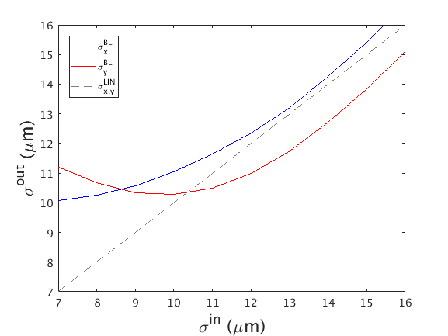

Figure 11 linearity in the response of the beamline to Twiss parameter modifications as suggested by the TRM method. A requested beam size of in (both in x and y) determines an actual size of the photon beam at the sample (out) with an almost linear response in the region [12,15] m, while for in<11m the response is markedly non-linear.

# Optimisation in Diamond-II

## Multi-Objective Beamline Tuning

In this section, the optimisation of two beamline configurations, I13-coherence and I20-scanning branches are considered. The interest in the two of them is that they receive their photons through an undulator and a wiggler respectively. Having covered two types of insertion devices, the conclusions of these two types of beamline to other situations can be extended.

~~For each of the two beamlines~~ we have considered four steps:

* optimization of beamline parameters only. For this stage, the Twiss parameters of the source are supposed to be known and fixed,
* beamline parameters are left fixed, with only the Twiss parameters allowed to change,
* both the beamline and Twiss parameters are considered in the optimisation.

For the three aforementioned cases we assume a fully coherent photon beam, as defined in the SRW code for the radiation emitted by the source. This justifies a fourth stage in our study where we explore whether the set of parameters that have been identified as potentially interesting, with respect to the objectives they yields, remain so in the more realistic case of a partly coherent radiation. The aim here will not be to perform a partially-coherent optimisation, but rather to evaluate how well can the conclusions drawn in fully-coherent configurations be considered as reasonable approximations of their partially coherent counterparts.

**3.1.1. I13 beamline-only optimisation**

In this case the accelerator lattice is imposed by the design, so the optimization runs solely on a subset of the beamline itself. For beamline I13, the parameters chosen are the last three drifts defining the inter-distances between specific optical elements. Referring to Fig. 3, these parameters are: the drift between the last crystal monochromator and the first elliptical mirror, the drift between the last two elliptical mirrors of the KB system, and the drift from the last elliptical mirror to the sample. In addition to these three parameters, we also consider the two focal distances (p,q) of each elliptical mirror of the KB system. The optimization runs therefore on a 7-dimensional space. The chosen objectives to be minimized are the horizontal and vertical beam sizes. The computation of the genetic algorithm runs on a population of 100 individuals and over ~~50 generations~~.

Table 4 Parameters used for the genetic optimisation, together with the objectives during several phases of NSGA evolution towards a beamline with a very small image at the sample plane. No real improvement is seen after 40 generations, suggesting the Pareto front has been reached for this problem. The last columns reports the increase of the beam-spot maximal intensity, which is not an objective in our optimization, but is directly linked to the formation of a smaller image.

|  |  |  |  |  |  |  |  |  |  |  |
| --- | --- | --- | --- | --- | --- | --- | --- | --- | --- | --- |
|  | (m) | | | | | | | (m) | | (ph/s/0.1%BW/mm2) |
| BL-config | d1 | d2 | d3 | p1 | q1 | p2 | q2 | x | y | I |
| baseline | 10 | 2.2 | 5.5 | 30.9 | 9.1 | 33.1 | 6.9 | 17.94 | 10.27 | 2.68e+17 |
| 4th gen. | 9.00 | 1.87 | 5.06 | 31.13 | 8.99 | 32.33 | 6.02 | 8.11 | 2.53 | 3.11e+18 |
| 40th gen. | 11.10 | 1.50 | 5.00 | 34.31 | 7.96 | 31.69 | 5.79 | 3.44 | 1.91 | 9.54e+18 |
| 66th gen. | 11.09 | 1.33 | 5.00 | 30.65 | 7.93 | 32.50 | 5.74 | 3.27 | 1.88 | 9.94e+18 |

The results, presented in table 4, illustrate how the horizontal and vertical beam sizes become more confined at sample position, as the number of computed generations increases. The intensity at centre is also presented, even though it is not an explicit objective. The table shows that between generations 40 and 50, the gain in beam size is fairly marginal. A closer look at the Pareto fronts in Figure 9 confirms that the objectives converge towards a smooth envelope describing the best set of configurations achievable. In Figure 13, the beam-spot sizes at sample are compared before and after the optimization.

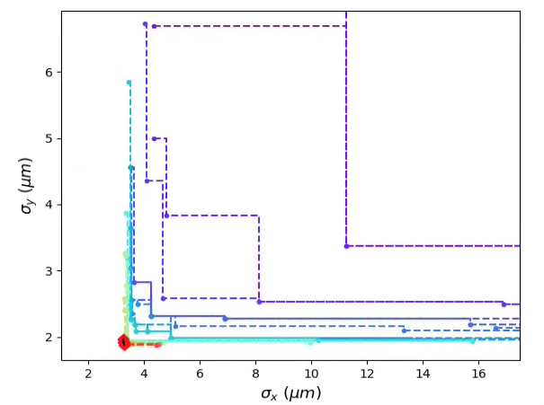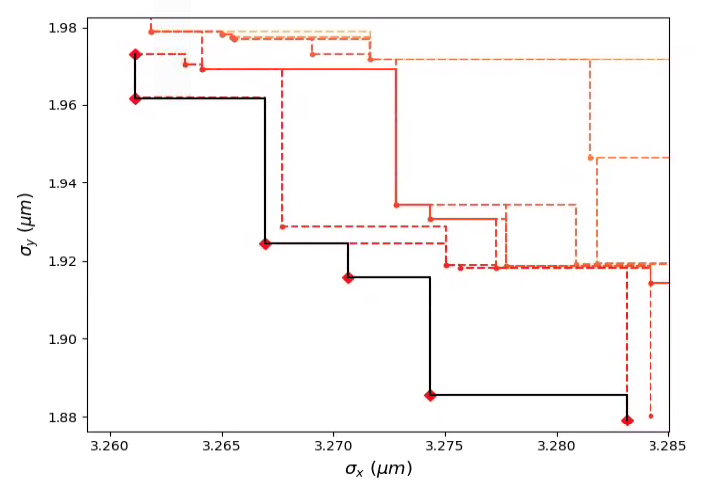

Figure 12 Front evolution for the multi-objective optimisation of beamline I13-coherence branch. The final front (red dots in the circled area of the left inset) identifies a region in the objective space where a very small beam can be produced. For the case under study an initial beam-spot of about (18, 10) m was compressed up to (3.3, 1.9) m (black circle). The right inset shows a zoon-in of the circled area. The new parameters corresponding to this solution are shown in Table 2 together with the initial configuration utilized for this test.

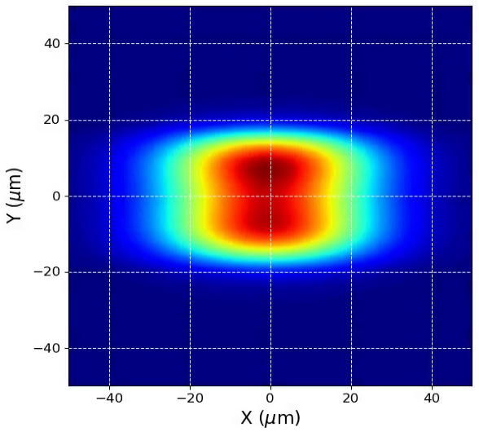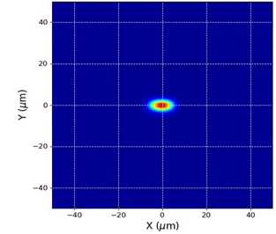

Figure 13 (Left) beam spot formed at sample for the I13-coherence branch before the optimisation of the beamline, showing a beam size of 18 m (10 m) in the horizontal (vertical) plane. (Right) the beam spot at the same location as it appears after optimising the beamline with the procedure described in the paragraph.

The above optimization started from a realistic known beamline design, which can be obtained for example as a first approach using ray-tracing methods. In order to check the robustness and effectiveness of the method we artificially spoiled the beamline parameters, producing an initial image at sample whose size is clearly unsatisfactory as shown in Table 5. On the same table it is shown how the algorithm converges towards objectives very close the case presented in Table 4.

Table 5 optimisation of a spoiled beamline (see text). The same process on the baseline case is reported in brackets for a quick comparison.

|  |  |  |  |  |  |  |  |  |  |  |
| --- | --- | --- | --- | --- | --- | --- | --- | --- | --- | --- |
|  | (m) | | | | | | | (m) | | (ph/s/0.1%BW/mm2) |
| BL-config | d1 | d2 | d3 | p1 | q1 | p2 | q2 | x | y | I |
| spoiled (baseline) | 9.88  (10) | 3.40  (2.2) | 6.87  (5.5) | 29.13  (30.9) | 7.97  (9.1) | 29.60  (33.1) | 6.81  (6.9) | 58.66  (17.94) | 74.82  (10.27) | 1.27e+16  (2.68e+17) |
| optimized from  spoiled (baseline) | 11.10 (11.09) | 1.50 (1.33) | 5.00 (5.00) | 34.31 (30.65) | 7.96 (7.93) | 31.69 (32.50) | 5.79 (5.74) | 3.44 (3.27) | 1.91 (1.88) | 9.54e+18 (9.94e+18) |

The convergence process, illustrated in Fig. 14, shows a phenomenon of “front transition”, where the algorithm converges to a first front that will gradually densely populate. At some point, the algorithm will “jump” to another front that will provide a better minimisation of the objectives, and gradually populate this second front. This mechanism occurs because the first front corresponds to a local minimum that can be escaped when a sufficient number of parameters have been explored, and is a feature of genetic optimisation well known *e.g.* in the MOGA optimisations used in the particle accelerator community. While it is not possible in advance to know whether another third front would appear, if the algorithm runs for a sufficiently large number of iterations, in practice, this matters little, because the important feature is that the optimisation is significantly reducing the beam size down to a solution that is comparable to what we would have from the baseline configuration.

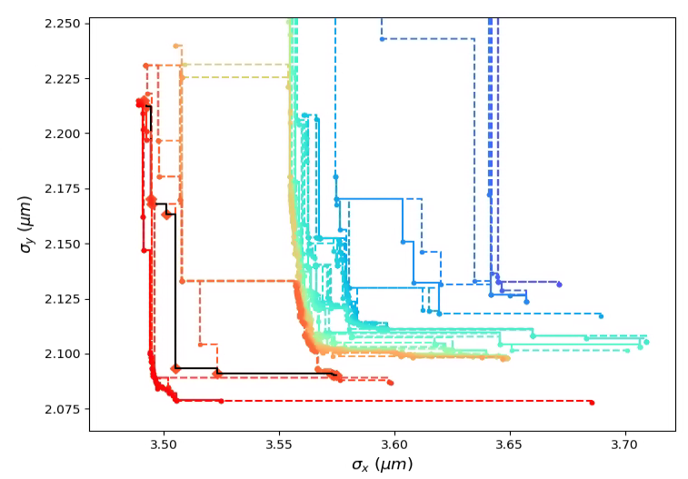

Figure 14 front progression for the spoiled beamline case illustrated in Table 5.

**3.1.2. I13 Twiss parameter-only optimisation**

In this section we study the effect of the Twiss parameters defining the electron beam at the source point, on the beam-spot at the sample plane of the beamline. To do this we assume the beamline parameters as fixed to specific values for the:

* nominal beamline case, generating a beam-spot of (18, 10) m,
* optimized beamline with an alteration of the Twiss parameters, determining a spoiled beam-spot of (55,2) m.

Tab. 6a and 6b show the results of the NSGA-II optimisation for these two cases. We can see how the result of the optimisation is largely driven by the beamline settings, with a minor effect from the accelerator optics. For the 6a case there is a marginal improvement in the beam-spot size due to a reduction of the beta functions at waist, but the result of the optimisation is well away from the tiny beam-spot reachable with the beamline tuning illustrated in the previous paragraph. In the 6b case we start from a well-tuned beamline, deliberately introducing a set of “wrong” Twiss parameters. The genetic algorithm is able to restore a small beam-spot of (3.2, 1.8) m, very close to the case seen in Table 4, by changing the beta functions and, remarkably, by re-setting the dispersion and its derivative to zero.

Table 6a I13 baseline configuration tuned with Twiss elements used as optimisation parameters

|  |  |  |  |  |  |  |  |  |
| --- | --- | --- | --- | --- | --- | --- | --- | --- |
|  |  |  | Accelerator Twiss parameters | | | | Objectives | |
|  |  |  |  |  |  |  |  |  |
|  |  | start (baseline) | 8.36 | 4.40 | 0 | 0 | 17.94 | 10.27 |
|  |  | end | 7.00 | 4.00 | 0 | 0 | 16.44 | 10.22 |

Table 6b I13 optimised beamline case, with initially spoiled Twiss elements that are used as optimisation parameters.

|  |  |  |  |  |  |  |  |  |
| --- | --- | --- | --- | --- | --- | --- | --- | --- |
|  |  |  | Accelerator Twiss parameters | | | | Objectives | |
|  |  |  |  |  |  |  |  |  |
|  |  | start (spoiled) | 9.06 | 9.63 | 1.29 | 0.07 | 55.12 | 2.31 |
|  |  | end | 10.84 | 3.30 | -1e-5 | 8e-6 | 3.15 | 1.81 |

The scope of this paper is limited to show that a set of Twiss parameter values exists that can achieve an optimisation under appropriate circumstances (*e.g.* the beamline has been initially optimised). Deciding which set of beta values to choose, requires other considerations beyond the scope of this work, namely since a selected set of Twiss parameters reflects locally and globally on the particle accelerator lattice, and crucially affecting its linear and non-linear dynamics. This will be explored in a future work.

**3.1.3. I13 Twiss parameter and Beamline Optics optimisation**

We now explore the general case where we allow both the Twiss and the beamline parameters to vary. Like previously, we first study a system starting from the given baseline, after which we look at the optimisation of an altered configuration determining a worse output at sample. Tables 4a and 4b illustrate the results of the genetic algorithm in these two cases. We see that the objective functions converge to a minimum that is fairly close in the two cases, that is, (3.57, 1.96) m and (3.57, 2.04) m respectively. It is interesting to notice how the Twiss parameters for both the baseline and the spoiled initial cases, tend towards the same values, i.e. (xw , yw )= (8.99, 4.00) m, within the numerical precision of our simulation.

Table 7 Optimisation of a full system from a baseline configuration for both machine and beamline (I13)

|  |  |  |  |  |  |  |  |  |  |  |  |  |  |
| --- | --- | --- | --- | --- | --- | --- | --- | --- | --- | --- | --- | --- | --- |
|  | Beamline parameters | | | | | | | Accelerator Twiss parameters | | | | Objectives | |
|  |  |  |  |  |  |  |  |  |  |  |  |  |  |
| Start | 10 | 2.2 | 5.5 | 30.9 | 9.1 | 33.1 | 6.9 | 8.36 | 4.40 | 0 | 0 | 17.94 | 10.27 |
| End | 12.99 | 1.24 | 5.41 | 29.37 | 8.56 | 31.68 | 6.33 | 8.99 | 4.00 | 0 | 0 | 3.46 | 1.96 |

Table 8 Optimisation of a full system from a spoiled configuration for both machine and beamline (I13)

|  |  |  |  |  |  |  |  |  |  |  |  |  |  |  |  |
| --- | --- | --- | --- | --- | --- | --- | --- | --- | --- | --- | --- | --- | --- | --- | --- |
|  |  | |  | |  | | | | | | | | | | |
|  | | Beamline parameters | | | | | | | | | Accelerator Twiss parameters | | | | Objectives | | |
|  | |  | |  | |  |  |  |  |  |  |  |  |  |  | |  |
| Start | | 11.87 | | 1.62 | | 6.17 | 29.05 | 6.05 | 31.00 | 10.52 | 7.67 | 5.24 | 0 | 0 | 65.91 | | 65.88 |
| End | | 12.97 | | 1.37 | | 5.57 | 30.62 | 8.94 | 32.86 | 6.50 | 8.99 | 4.00 | 0 | 0 | 3.57 | | 2.04 |

Similarly, the Pareto-values obtained for the beamline-components of the parameter space converge to values that are very close to each other, although not completely identical. This type of convergence to neighbouring values is common in many iterative optimization methods used in x-ray image reconstruction. What we observe here specifically, is very much similar to the so-called “ordered subset expectation maximization” method (OSEM), where several systems will converge toward very close values to the “ideal true value” of the system. In the OSEM technique, there is usually a contribution from the noise. This role is played here by the randomness introduced at each iteration of the genetic algorithm when the new individuals of the new population are generated. Now, comparing the final parameters, we see that, for the unspoiled and spoiled cases, converges to 12.99 and 12.97, to 1.24 and 1.37, and to 5.41 and 5.57. This gives an overall length of 19.64 and 19.91. One should bear in mind that the original length for d1+d2+d3 was 17.7 meters, which means that both optimisations require an increase of the overall length by about 2 meters.

Variations of this entity may be impractical to implement on an already built system, while a change in the spatial distribution of beamline elements is perfectly thinkable at a design stage.

For the I13 case we explored the possibility of describing the beamline by means of a full transport matrix that acts on an initially defined photon phase space. This assumes the linearity of the system and entails a definition of the photon beam as the convolution of the electron beam phase space with a coherent photon source. The photon beam moments can be defined as:

$$S=\left[\begin{matrix}\begin{matrix}s_{xx} & s_{xx'} \\ s_{x'x} & s_{x'x'}\end{matrix} & \begin{matrix}s_{xy} & s_{xy'} \\ s_{x'y} & s_{x'y'}\end{matrix} \\ \begin{matrix}s_{yx} & s_{yx'} \\ s_{y'x} & s_{y'x'}\end{matrix} & \begin{matrix}s_{yy} & s_{yy'} \\ s_{y'y} & s_{y'y'}\end{matrix}\end{matrix}\right]=\left[\begin{matrix}\begin{matrix}s_{xx} & s_{xx'} \\ s_{xx'} & s_{x'x'}\end{matrix} & \begin{matrix}0 & 0 \\ 0 & 0\end{matrix} \\ \begin{matrix}0 & 0 \\ 0 & 0\end{matrix} & \begin{matrix}s_{yy} & s_{yy'} \\ s_{yy'} & s_{y'y'}\end{matrix}\end{matrix}\right]$$

Where we have assumed a complete decoupling between the horizontal and the vertical plane. Each element of this matrix is a Gaussian convolution of the electron beam moments, derived from the optical properties of the lattice at the source point:

$$s_{zz}^{e}=β_{z}ϵ_{z}+{\left(D_{z}δ_{E}\right)}^{2}$$

$$s_{z'z'}^{e}=γ_{z}ϵ_{z}+{\left(D_{z'}δ_{E}\right)}^{2}$$

$$s_{z'z}^{e}=s_{zz'}^{e}{=α}_{z}ϵ_{z}+D_{z}D_{z'}δ_{E}^{2}$$

and the photon moments, given by:

$$s_{zz}^{ph}=\frac{l_{ph}L_{und}}{8π^{2}}$$

$$s_{z'z'}^{ph}=l_{ph}^{}/(L_{und}^{} )$$

$s_{zz'}^{ph}=0$

With z=(x,y).

Given an initial photon beam envelope defined by the aforementioned moments, the final beam is easily found as:

$$S_{fin}=MS_{ini}M^{T}$$

Where M is the the overall transport matrix for the beamline derived as a matrix product of the single beamline elements:

$M=m_{n}…m_{2}m_{1}$

I13-coherence was then optimised for a lattice of Diamond-II with both the previously described full SRW wave front propagation, and by means of the matrix method.

Chosen optimised points with similar features show very similar intensity distributions, most likely related to the use a fully-coherent beam and ideal optics.

This illustrates how a simplified matrix approach to the problem might be used for quick optimisations, while a more thorough treatment of non-lienarities, aberrations and element imperfections should be tackled by means of a full SRW simulation approach.

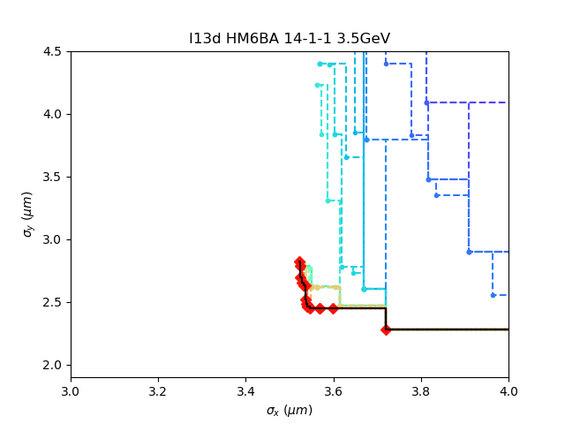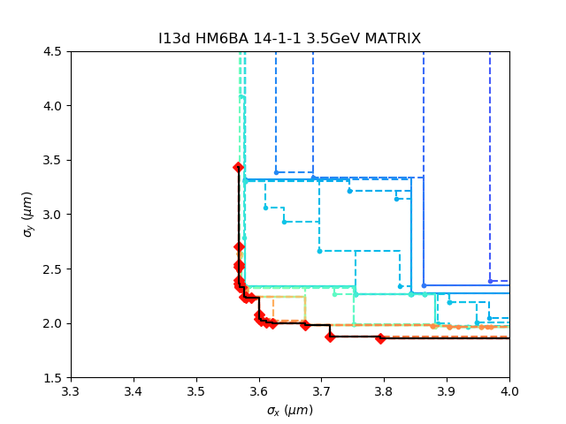

Figure 15 optimisation of beamline I13, both with a full SRW wave-front propagation (left) and with a simplified model based on a matrix description of the beam and key elements (right). For both cases the final Pareto front appears to be located in the same objective region.

**Imperfection of mirrors**

In SRW, we could introduce the imperfection to mirrors by using the height error as a function of position along the length of the mirror. Then get the path length correction for the wavefront[]. Fig.16 shows the beamspot at sample position of I13 coherence branch with perfect beamline(left) and with imperfection beamline(right). The beam size is marginally changed while the imperfection blurred the spot obviously.

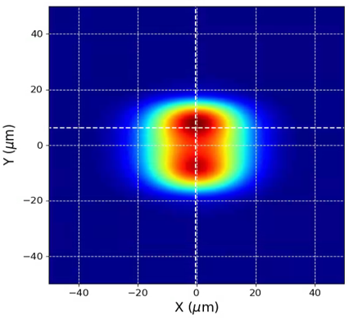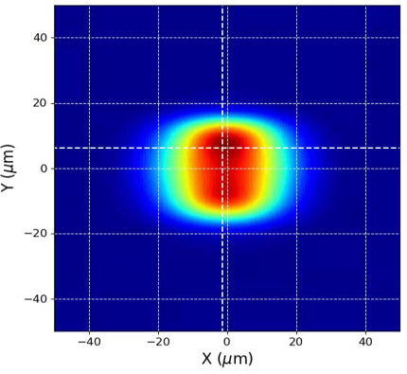

Fig16. Beam spot at the sample position of I13 coherence branch with ideal mirrors (left) and imperfect mirrors (right).

**3.1.4. I20 beamline-only optimisation**

Another beamline optimization was performed on beamline I20-scanning branch. The SRW model considered for this beamline is illustrated in Fig. 8.

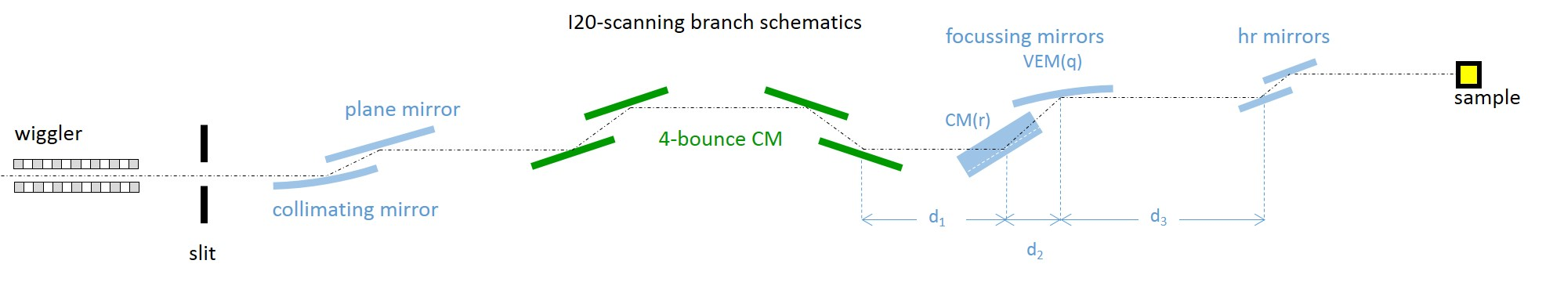

Figure 16 A schematic side view of DLS beamline I20 scanning branch model used in this study.

For this problem the genetic optimization of the beamline was performed on the current 3 GeV Diamond machine. One of the particular challenges of the photon behavior at sample position, is that it exhibits two winged lobes that breaks the symmetry that would have been desired, and as a result. This complicates considerably the post-processing of results and data analysis. The genetic optimisation has therefore been applied on this system. Several options could have been imagined to try making the lobes disappear. Here the hypothesis explored was to minimize the end of the photon distribution at sample. The parameters used, were the five elements descriptors that follows immediately the last crystal monochromators along the beamline, that is: the first drift afterward, the sagittal radius of the toroid that follows it, the length of the drift after, the radius of the vertically deflecting mirror and the drift that follows.

The optimization process has been run for 30 generations each having a population of 100 individuals calculated in parallel on a cluster. This beamline configuration is computationally much more intensive due to the time required in SRW to calculate the initial wave-front from a wiggler. The Figure 1 and 2 show the baseline configuration and final one, respectively, and the comparison shows that the optimization is clearly successful in removing the lobes. The final configuration has been picked from the final Pareto front shown in the Fig 3. It ought to be noted that the density of Pareto lines in the Fig 3 shows that the simulations converges, as the Pareto lines becomes more and more close. As a result, the convergence here, is essentially achieved after 30 generations and this justifies to pick up a point from the Pareto front produced at 30 generations, instead of waiting much longer.

Table 4 shows a more quantitative description of how the optimization of the two objectives vary with the corresponding parameters. Crucially, it must be noted that the beamlines parameters vary within a range of values that is experimentally achievable, proving that the genetic algorithm is a sensible approach in investigating the design of realistic beamlines structures.

Table 9 This table shows the parameters used for the genetic optimizations of the I20-Scanning beamline and the two objectives obtained for each set

|  |  |  |  |  |  |  |  |  |
| --- | --- | --- | --- | --- | --- | --- | --- | --- |
|  | parameters | | | | | Objectives | | Intensity |
| d1 (m) | CM-radius (m) | d2 (m) | VEM-q (m) | d3 (m) | x (m) | y (m) | I (ph/s/0.1%BW/mm2) |
| Baseline config. | 2.7 | 0.087 | 4.5 | 23 | 19.5 | 237.04 | 49.45 | 4.51e+11 |
| generation 25 | 2.32 | 0.084 | 5.23 | 21.32 | 18.11 | 163.32 | 31.85 | 1.067e+12 |
| generation 30 | 3.75 | 0.084 | 4.05 | 21.01 | 18.14 | 126.16 | 27.28 | 1.31e+12 |

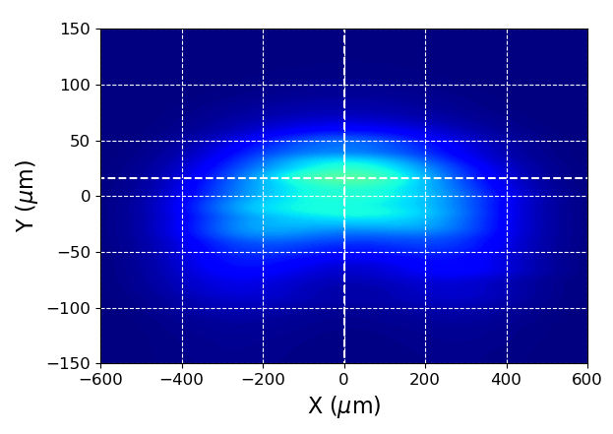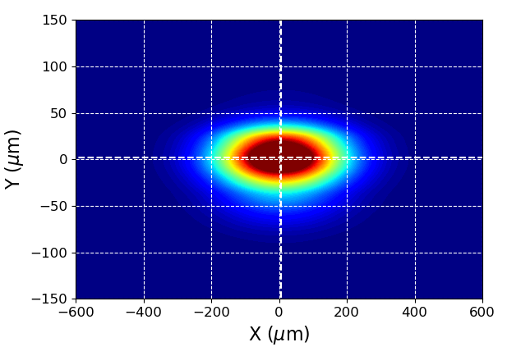

Figure 17 (Top) beamspot at sample for beamline I20-scanning branch for the baseline configuration of the system, (bottom) image at sample after 30 generations of the genetic optimiser. The size of the beamspot is nearly halved and the two side wings are removed.

## Beamline Response Matrix

In a similar way as shown in paragraph 2.2, we explored the effect of the modification of beamline parameters on the objectives characterizing the system. In doing this we make the implicit assumption that the system is linear, at least within a certain domain around a defined working point. Small modifications of the parameters defining the beamline, allow the calculation of a beamline response matrix (BRM) which can then be used to improve the performance of the beamline itself. Fig. xxx shows an example of this technique applied to the case of beamline I20 scanning branch, whose schematic is shown on Fig. 6. For this test we used the same set of parameters taken into account for the MO optimisation described in paragraph 3.1. Starting for the same initial configuration used for the MO case, we can show that the BRM approach is quite effective, however when the starting point is chosen randomly, i.e. when the initial beamline is performing badly, the linear strategy offered by the BRM is not effective while the NSGAII optimisation algorithm can find better solutions, even in presence of an ill conditioned system.

The two approaches appear therefore complementary and confirm the experience matured in the AP community: a MO strategy allows to tackle complex situations without prior knowledge of the system, with good chance of reaching attractive solutions at the expense of long computing times. Vice-versa, the response matrix based approach is very fast, but requires to be fairly close to the best solution. If this is not the case, the often intrinsic non-linearity of the problem may conduct to bad or even non-physical solutions.

The BRM technique was studied for beamline I20 scanning branch where we used the same parameters involved in the NSGAII optimisation as seen in Fig. 8 and also in Table 3. Starting from the baseline configuration we recorded the beam size variations corresponding to a 1% change in the parameters, thus building the BRM for I20. A pseudo-inverted matrix is obtained by standard SVN decomposition which can be used to infer the parameter variations needed to produce the requested variations of the objectives. Fig. 18 illustrates the real variations with respect to a baseline configuration seen in the beamline for a requested change in a parameter (red line). This result can be compared with the simple linear prediction (dashed blue line). It is apparent how the linear response of the system is satisfied only for a close region around the working point (see inset of Fig. 18). For large requested variations linearity is broken, in particular a negative change may be in conflict with the focussing nature of the system (beam size is positive defined), as clearly seen in Fig. 18 where a quadratic behaviour appears around a minimum. Starting from an initial sx = 245um, it can be seen that the BRM method allows to reach a beamspot 16% larger than the value obtained with the optimisation described in Par. 3.1 (126um)

This discrepancy is exacerbated if starting from an initially bad beamline configuration. Considering a deliberately spoiled beamline we tried to reduce an in initial beam-spot a sample with sx = 10.4mm by using a BRM computed around this working point. The non-linearity case is even stronger, as seen in Fig. 11, and we cannot get better than a 3mm spot at sample.

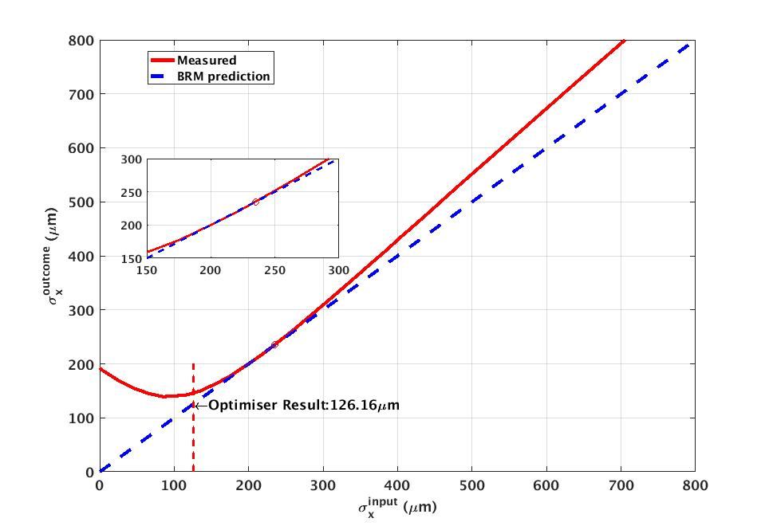

Figure 18 Response matrix optimisation results for present I20 beamline.

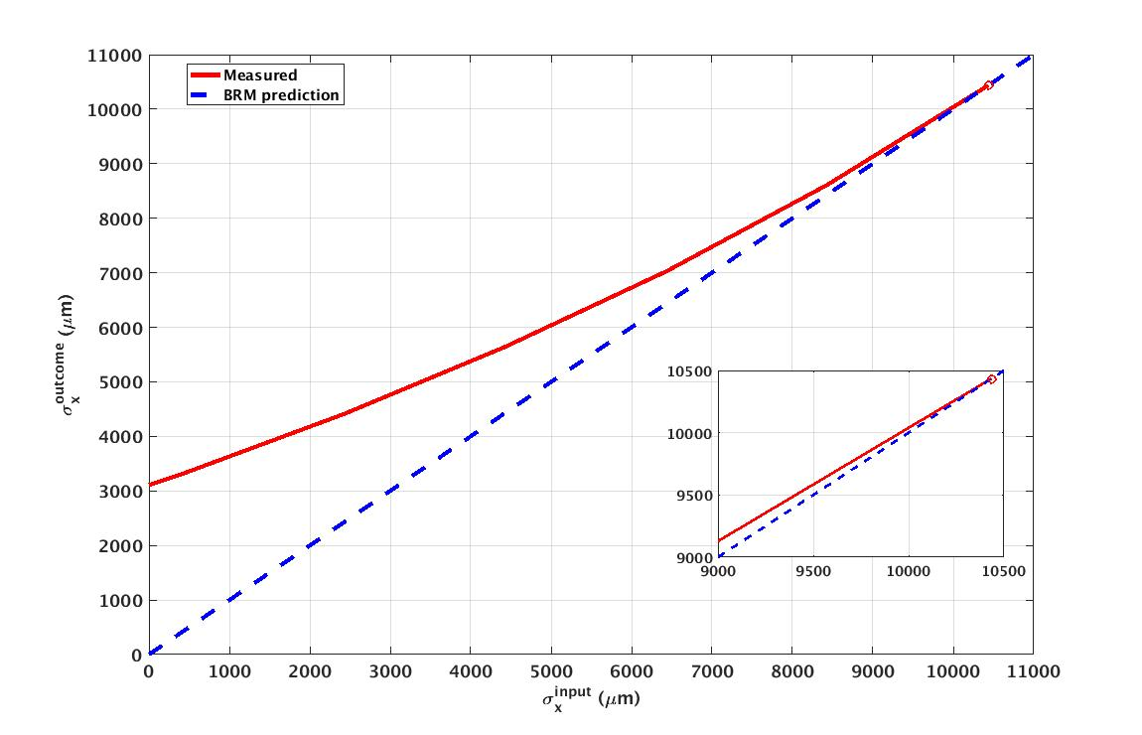

Figure 19 Response matrix optimisation for a spoiled configuration of I20 where the initial sx was inflated to 10.4mm.

## Conclusions

In the context of the development of a new machine (Diamond-II) we have illustrated the use of a python based code combining some existing on-shelf packages to define the machine input parameters and the SR propagation in a beamline. This allows investigation of source point variations and optimisation of beamline parameters by means of multi-objective techniques. Comparison with response matrix linear techinques are also analysed.

The next steps include a further use of the electron tracking code, to include a re-definition of the lattice in the optimisation procedure.

## Acknowledgments

**References**

[1] M. Borland, “elegant: A Flexible SDDS-Compliant Code for AcceleratorSimulation", Advanced Photon Source, US, LS-287, 2000.

[2] O. Chubar, P.Elleaume, "Accurate and Efficient Computation of Synchrotron Radiation in the Near Field Region", in Proc. Conf. EPAC98, Stockholm, Sweden, Jun. 1998, pp. 1177-1179.

[3] M. Sanchez del Rio et. al., "SHADOW3: a new version of the synchrotron X-ray optics modelling package", in J. Synchrotron Radiation, vol. 18(Pt 5), pp. 708-716, 2011.

[4] R.P. Walker et al., The Double-Double Bend Achromat (DDBA) Lattice Modification for the Diamond Storage Ring, in Proc. Conf. IPAC2014, Dresden, Germany, June 2014, paper MOPRO103, pp. 331-333.

[5] “Diamond-II, Conceptual Design Report", C. Abraham et al., [*https://www.diamond.ac.uk/Home/About/Vision/Diamond-II.html*](https://www.diamond.ac.uk/Home/About/Vision/Diamond-II.html)

[] C.Rau, U. Wagner, A. Peach, I. K. Robinson, B. Singh, G. Wilkin, and C. Jones, “The Diamond Beamline I13L for Imaging and Coherence”, AIP Conference Proceedings 1234, 121 (2010), doi.org/10.1063/1.3463156

[] S. Stepanov, “X0h on the web”, [*https://x-server.gmca.aps.anl.gov/x0h.html*](https://x-server.gmca.aps.anl.gov/x0h.html).

[8] M. Apollonio, L. Alianelli, F. Bakkali Taheri, R. Bartolini, A. Dent, J. Li, Evaluating the Impact of Diamond-II possible lattices on beamlines, IPAC2018, Vancouver (CA), April 2018, paper THPMF005